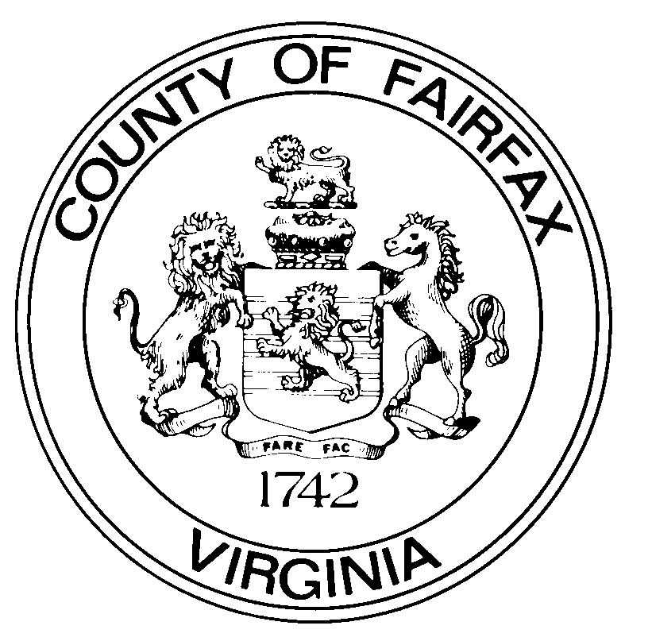

COMMONWEALTH OF VIRGINIA

Suite 530

12000 GOVERNMENT CENTER PARKWAY

FAIRFAX, VIRGINIA 22035-0071

___________

TELEPHONE 703- 324-2321

FAX 703- 324-3955

chairman@fairfaxcounty.gov

**COUNTY OF FAIRFAX**

BOARD OF SUPERVISORS

FAIRFAX, VIRGINIA 22035

JEFFREY C. MCKAY

CHAIRMAN

September 21, 2022

Hon. Paul Smedberg, Chair

Washington Metropolitan Area Transit Authority

300 7th Street SW

Washington, DC 20024

Re: Action Item III-A

Dear Chairman Smedberg:

I am surprised and dismayed by Action Item III-A “Greenbelt Joint Development Approvals” slated for WMATA Board consideration at your meeting on September 22. An affirmative vote on this Item would be perceived as a de facto endorsement by WMATA, a regional entity, in a federal procurement competition between two Compact signatories. I hope you will withdraw the item and instead direct WMATA staff to work with your Board and approach this issue in a more transparent and fair manner that does not favor one site over another.

While I support WMATA’s use of its real estate holdings for development, I strongly oppose such use when it comes at the expense of any Compact signatory. Furthermore, the Board Item claims the selection of the Greenbelt site will lead to ridership increases and facility upgrades. This is also applicable to the Springfield site adjacent to the Franconia-Springfield Metro Station, which analysis has shown will also lead to increased ridership. Furthermore, the improvements Fairfax County and Virginia have made to the area greatly improve access to the site which, in turn, significantly benefit Metro, to say nothing of improvements that will be made should Springfield be selected. The construction of the Frontier Drive Extension will not only serve the FBI site, but will significantly improve access to the Franconia-Springfield Metro Station. This will also have a positive impact on Metrorail ridership. As the benefits to the Metro system would be at the very least equal between the Springfield and Greenbelt sites, implying that the Greenbelt site accrues additional benefits is disingenuous and inappropriate for a regional body that is funded by and that serves the District of Columbia, Maryland and Virginia.

In addition to the perception of endorsement created by this Item, it does not include updated key facts of the procurement as described in President Biden’s FY2023 Budget. For instance, the Item says the site could be up to 2.1 million square feet. This number was included in the procurement that was cancelled in 2017 which envisioned a fully consolidated suburban headquarters with 10,600 employees. The new procurement is smaller, with 7,500 employees. Furthermore, if WMATA were to enter into a Joint Development Agreement without competitive solicitation as proposed it would be doing so in violation of its own Joint Development Program Guidelines. This is acknowledged only once in the Item’s summary but is not included in the Resolution for the Board.

For WMATA to engage in this highly watched and publicized economic development procurement process in a manner that is completely lacking in cooperation and transparency is unacceptable. WMATA has received substantial criticism for a consistent lack of transparency surrounding major decisions it makes and this is another unfortunate example of this problem.

**For these reasons, I request that the Action Item III-A “Greenbelt Joint Development Approvals” be withdrawn and that any action by WMATA necessary to meet the requirements set forth by GSA must only be taken after a site is selected. If the Board chooses not to withhold action until after site selection, I ask that the Board direct WMATA staff to meet with the jurisdictions to approach this issue in a transparent way and that treats all sites under consideration fairly.**

Sincerely,

Jeffrey C. McKay

cc: Board of Directors, WMATA

Randy Clarke, General Manager

The Honorable Mark Warner, U.S. Senate

The Honorable Tim Kaine, U.S. Senate

The Honorable Gerald Connolly, U.S. House of Representatives

The Honorable Don Beyer, U.S. House of Representatives

The Honorable Jennifer Wexton, U.S. House of Representatives

Members, Fairfax County Board of Supervisors